**TEST CASE: 001**

**TEST DATE:** December 5, 2019 ~ 2:30PM

**TESTER:** Keith Estrella

**SCENARIO:** Daily Database Update and Processing

|  |  |  |  |  |  |
| --- | --- | --- | --- | --- | --- |
| **STEP** | **TEST** | **EXPECTED** | **ACTUAL** | **PASS/FAIL** | **COMMENTS** |
| 1 | Using custom program, check if database has been updated. | Program compares yesterday’s and today’s database and prints out what is missing in both, therefore it has been updated. | Program returns entries not found in yesterday’s database. | PASS | A review on the resulting entries show that Dec 5 entries are found only in today’s database. |
| 2 | Check for RFEM Company Info | Should return the matching info of the company | Returned expected | PASS |  |
| 3 | Check for GOOGL Company Info | Should return the matching info of the company | Returned expected | PASS |  |
| 4 | Check for UNH Company Info | Should return the matching info of the company | Returned expected | PASS |  |

**ADDITIONAL TEST NOTES**

Daily Update Results Lists are from Dec 4th and Dec 5th

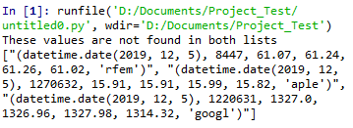

**TEST CASE: 002**

**TEST DATE:** December 11, 2019 ~ 10:40PM

**TESTER:** Keith Estrella

**SCENARIO:** Front-End User Interface

|  |  |  |  |  |  |
| --- | --- | --- | --- | --- | --- |
| **STEP** | **TEST** | **EXPECTED** | **ACTUAL** | **PASS/FAIL** | **COMMENTS** |
| 1 | Connect to website. | Should connect and display front page. | As expected. | PASS |  |
| 2 | Click on the changes tab. | Changes webpage to display change calculation with provided user input. | As expected. | PASS |  |
| 3 | Select date range, between Nov 7, 2019 and Dec 7, 2019. | User input should work and select the respective dates. | As expected. | PASS |  |
| 4 | Select computation type. | Computation type changes to user input. | As expected. | PASS |  |
| 5 | Select Symbol. | User should be able to change Symbol for each company. | As expected. | PASS |  |
| 6 | Click calculate to calculate the computation. | Should return the result of the computation with given user input. | Returns as expected. | PASS | However it does send it back to the Chart page, clicking Changes will send it back and give the answer above. |

**ADDITIONAL TEST NOTES**

Results from RFEM testing.

MIN:

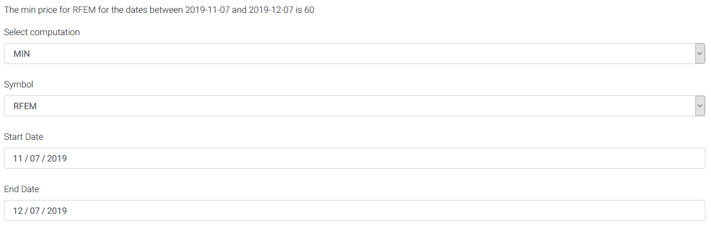

MAX:

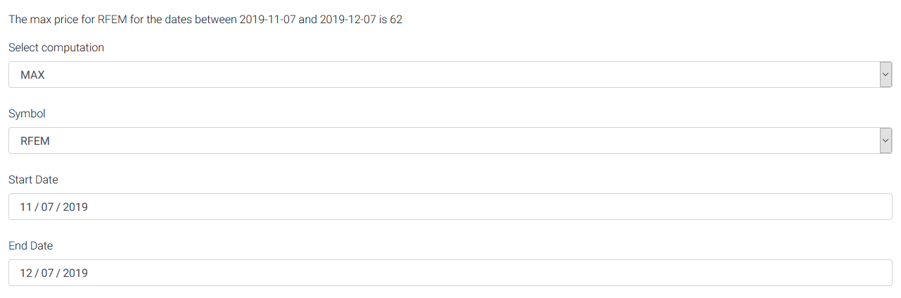

MEAN:

